24CSI024-DATA STRUCTURES AND ALGORITHMS
UNIT 1-INTRODUCTION TO DATA STRUCTURES AND ALGORITHMS
Arrays and Array-Based Techniques (Two-Pointer, Sliding Window, Prefix Sums) LAB WORKBOOK-16.07.2026

ROLL-NO : 25BAD123

CATEGORY: EASY

Question 1: Merging Two Sensor Logs (Two-Pointer)
Two weather stations, A and B, each recorded temperature readings independently and stored them in non-decreasing sorted order. Divya needs to merge both logs into a single sorted array for her analysis dashboard — without using any built-in sort function, and in O(N + M) time.
She uses the two-pointer merge technique:
- Initialize a pointer i at index 0 of array A and a pointer j at index 0 of array B.
- Compare A[i] and B[j]. Copy the smaller value into the output array and advance that pointer.
- Repeat until one array is exhausted.
- Copy any remaining elements of the other array directly into the output.
  - The first line of input consists of two space-separated integers N and M — the sizes of arrays A and B.
  - The second line consists of N space-separated integers (array A, sorted).
  - The third line consists of M space-separated integers (array B, sorted).
  - Print a single line of N + M space-separated integers representing the merged sorted array.
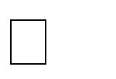

  - 1 N, M 10000



  - 10⁴ arr[i] 10⁴

Input 1: Input 2:

3 4  1 5 9  2 3 8 | 2 2  0 0  -1 4
Output: Output:

5 8 9 10 | -1 0 0 4

Aim:

To merge two sorted arrays into a single sorted array using the Two-Pointer technique.

START

Read N and M
Read array A
Read array B
Set i = 0, j = 0, k = 0

Pseudo Code:

WHILE i < N AND j < M
IF A[i] <= B[j]
result[k] = A[i]
i = i + 1
ELSE
result[k] = B[j]
j = j + 1
END IF
k = k + 1
END WHILE

WHILE i < N
result[k] = A[i]
i = i + 1
k = k + 1
END WHILE

WHILE j < M
result[k] = B[j]
j = j + 1
k = k + 1
END WHILE

Print result array
STOP

C Program :

#include <stdio.h>

int main()
{
int n, m;
scanf("%d %d", &n, &m);

int a[n], b[m], result[n + m];

for (int i = 0; i < n; i++)
scanf("%d", &a[i]);

for (int i = 0; i < m; i++)
scanf("%d", &b[i]);

int i = 0, j = 0, k = 0;

while (i < n && j < m)
{
if (a[i] <= b[j])
{
result[k] = a[i];
i++;
}
else
{
result[k] = b[j];
j++;
}
k++;
}

while (i < n)
{
result[k] = a[i];
i++;
k++;
}

while (j < m)
{
result[k] = b[j];
j++;
k++;
}

for (i = 0; i < n + m; i++)
printf("%d ", result[i]);

return 0;
}

Output :

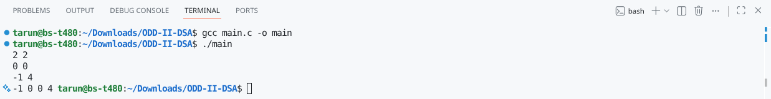

Question 2: Locating the First Below-Threshold Reading (Linear Search)
Farhan monitors battery voltage readings from a fleet of IoT sensors, logged in
the order they were received (not sorted). He needs to find the position of the first reading that drops below a safe voltage threshold T, so maintenance can pinpoint when the fault began.
  - The first line of input consists of two space-separated integers N and T.
  - The second line consists of N space-separated integers representing the voltage readings, in the order recorded.

  - Print a single integer: the 0-indexed position of the first reading strictly less than T. If no such reading exists, print -1.


  - 1 N 10000
  - 10³ arr[i], T 10

Input 1: Input 2:

6 5  9 7 6 4 8 3 | 4 0  1 2 3 4

Output: Output:

3 | -1

Aim:

To find the position of the first element that is less than the given threshold using the Linear Search technique.

Pseudo Code:

START
Read N and T
Read array

FOR each element in the array
IF element < T
Print its index
STOP
END IF
END FOR

Print -1
STOP

C Program:

#include <stdio.h>

int main()

{

int n, t;

scanf("%d %d", &n, &t);

int arr[n];

for (int i = 0; i < n; i++)

scanf("%d", &arr[i]);

for (int i = 0; i < n; i++)

{

if (arr[i] < t)

{

printf("%d", i);

return 0;

}

}

printf("-1");

return 0;

}

Output :

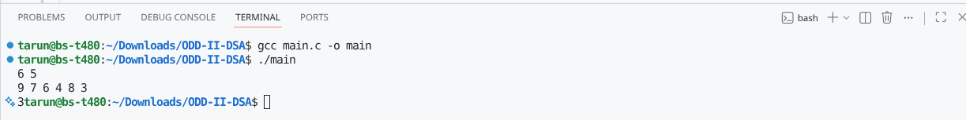

CATEGORY: MEDIUM

Question 3: Maximum Rainwater Between Towers (Two-Pointer)
A telecom company has N transmission towers of varying heights standing in a row. During heavy rain, water can collect in the “well” formed between two towers, bounded by the shorter of the two. Meera wants to find the two towers that can trap the maximum volume of water between them, so she can plan drainage.
She solves it in O(N) using two pointers instead of checking every pair:
- Initialize left = 0 and right = N - 1, and maxWater = 0.
- Compute the water trapped between left and right: min(height[left], height[right]) * (right - left). Update maxWater if this is larger.
- Move the pointer at the shorter tower inward — it can never form a better pair with anything closer than the taller side already offers.
- Repeat until left meets right.
  - The first line of input consists of an integer N — the number of towers.
  - The second line consists of N space-separated non-negative integers representing tower heights.
  - Print a single integer representing the maximum water that can be trapped, in the
format: Max Water: X.


  - 2 N 10000
  - 0 height[i] 10

Input 1: Input 2:

5  2 5 4 8 3 7 | 4  1 1 1 1

Output: Output:

Max Water: 49 | Max Water: 3

Aim:

To find the maximum amount of water that can be trapped between two towers using the Two-Pointer technique.

Pseudo Code:

START

Read N

Read height array

Set left = 0

Set right = N - 1

Set maxWater = 0

WHILE left < right

Find minimum of height[left] and height[right]

Calculate water = minimum height × (right - left)

IF water > maxWater

maxWater = water

END IF

IF height[left] < height[right]

left = left + 1

ELSE

right = right - 1

END IF

END WHILE

Print maxWater

STOP

C Program:

#include <stdio.h>

int main()

{

int n;

scanf("%d", &n);

int height[n];

for (int i = 0; i < n; i++)

scanf("%d", &height[i]);

int left = 0;

int right = n - 1;

int maxWater = 0;

while (left < right)

{

int minHeight;

if (height[left] < height[right])

minHeight = height[left];

else

minHeight = height[right];

int water = minHeight * (right - left);

if (water > maxWater)

maxWater = water;

if (height[left] < height[right])

left++;

else

right--;

}

printf("Max Water: %d", maxWater);

return 0;

}

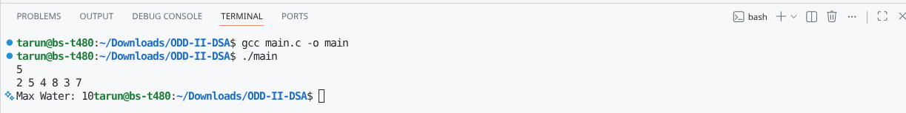
Output :

Question 4: Finding the Insertion Point for a New Calibration Value (Binary Search)
A lab keeps a sorted array of calibration reference values. Whenever a new value arrives, Ibrahim needs to find the exact index where it should be inserted to keep the array sorted — without scanning the whole array.
He uses a binary search variant that finds the first index whose value is greater than or equal to the new value:
- Initialize low = 0, high = N.
- While low < high: compute mid = low + (high - low) / 2.
- If arr[mid] < target, set low = mid + 1. Otherwise, set high = mid.
- When the loop ends, low is the correct insertion index.
  - The first line of input consists of two space-separated integers N and target.
  - The second line consists of N space-separated integers in non-decreasing order.
  - Print a single integer: the index at which target should be inserted, in the format: Insert At: X.


  - 1 N 10000



  - 10⁴ arr[i], target 10⁴

Input 1: Input 2:

6 | 29 |  |  |  |  | 4 | 5
10 | 20 | 30 | 40 | 50 | 60 | 1 | 2 | 3 | 4

Insert At: 2 | Insert At: 4
Output: Output:

Aim:
To find the correct insertion position of a target value in a sorted array using the Binary Search technique.

Pseudo Code:
START
Read N and target
Read array

Set low = 0
Set high = N

WHILE low < high
mid = (low + high) / 2

IF array[mid] < target
low = mid + 1
ELSE
high = mid
END IF
END WHILE

Print low
STOP

C Program:
#include <stdio.h>

int main()
{
int n, target;
scanf("%d %d", &n, &target);

int arr[n];

for (int i = 0; i < n; i++)
scanf("%d", &arr[i]);

int low = 0;
int high = n;

while (low < high)
{
int mid = low + (high - low) / 2;

if (arr[mid] < target)
low = mid + 1;
else
high = mid;
}

printf("Insert At: %d", low);

return 0;
}

Output :

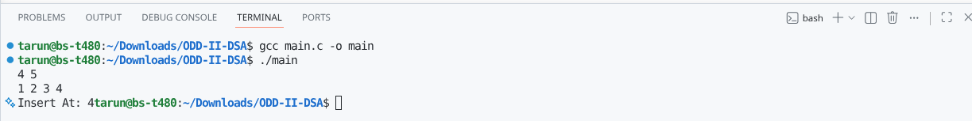

CATEGORY: HARD

Question 5: Locating a Packet in a Rotated Log Buffer (Modified Binary Search)
A circular network buffer stores log entries sorted by timestamp, but because it wraps around, the array as read out is a rotated sorted array (e.g., the oldest entries appear after the newest due to the wraparound point). Sana needs to locate a specific timestamp T in O(log N) time — a plain binary search won’t work directly since the array isn’t fully sorted end-to-end.
She adapts binary search to handle the rotation:
- Initialize low = 0, high = N - 1.
- Compute mid. If arr[mid] == target, return mid.
- Determine which half (low to mid, or mid to high) is properly sorted by comparing arr[low] and arr[mid].
- Check if target lies within the value range of the sorted half. If it does, recurse/iterate into that half; otherwise, search the other half.
- Repeat until found or the range is empty.
  - The first line of input consists of two space-separated integers N and target.

  - The second line consists of N space-separated distinct integers representing the rotated sorted array.
  - Print a single integer: the 0-indexed position of target in the array, in the format: Found At: X. If not present, print Found At: -1.


  - 1 N 10000



  - 10⁵ arr[i], target 10⁵
  - The array is a sorted array rotated at some unknown pivot; all elements are distinct.

Input 1: Input 2:

7 0  4 5 6 7 0 1 2 | 5 3  4 5 6 7 8
Output: Output:

Found At: 4 | Found At: -1

Aim:
To find the position of a target element in a rotated sorted array using the Modified Binary Search technique.

Pseudo Code:
START
Read N and target
Read array

Set low = 0
Set high = N - 1

WHILE low <= high
Find mid

IF array[mid] == target
Print mid
STOP
END IF

IF left half is sorted
IF target lies in left half
high = mid - 1
ELSE
low = mid + 1
END IF
ELSE
IF target lies in right half
low = mid + 1
ELSE
high = mid - 1
END IF
END IF
END WHILE

Print -1
STOP

C Program:
#include <stdio.h>

int main()
{
int n, target;
scanf("%d %d", &n, &target);

int arr[n];

for (int i = 0; i < n; i++)
scanf("%d", &arr[i]);

int low = 0;
int high = n - 1;

while (low <= high)
{
int mid = low + (high - low) / 2;

if (arr[mid] == target)
{
printf("Found At: %d", mid);
return 0;
}

if (arr[low] <= arr[mid])
{
if (target >= arr[low] && target < arr[mid])
high = mid - 1;
else
low = mid + 1;
}
else
{
if (target > arr[mid] && target <= arr[high])
low = mid + 1;
else
high = mid - 1;
}
}

printf("Found At: -1");

return 0;
}

Output
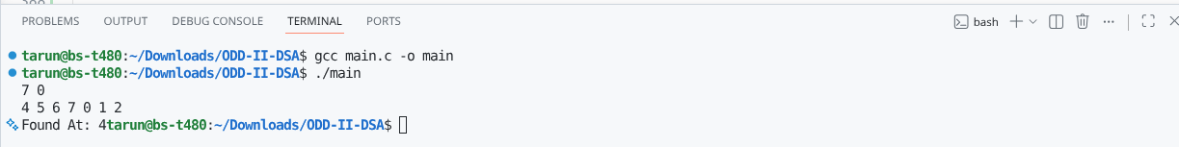

:

VIVA QUESTIONS:

1. In binary search, why must the array be sorted? What breaks if it isn't?
Binary search works only on a sorted array. When we compare the middle element with the target, we can decide whether to search the left half or the right half. If the array is not sorted, we cannot know which half contains the target, so we may discard the wrong half and miss the element.

2. Contrast the worst-case and best-case time complexity of linear search. When can linear search be faster than binary search?
Best case: O(1) (the first element is the target).
Worst case: O(N) (the target is the last element or not present).
Linear search can be faster when the array is small or when the target is near the beginning. It also works on unsorted arrays, whereas binary search needs a sorted array.

3. In a rotated sorted array, why can't we simply check if arr[mid] < target like standard binary search?
A rotated array is not completely sorted, so comparing only arr[mid] with the target is not enough. We must first find which half is sorted, and then check if the target lies in that sorted half.

4. Why is merging two sorted arrays using two pointers better than sorting the combined array again?
The two-pointer method uses the fact that both arrays are already sorted. It merges them in O(N + M) time. If we combine the arrays and sort again, it takes O((N + M) log(N + M)), which is slower because it performs unnecessary sorting.

5. Why is it safe to move the pointer at the shorter tower in the rainwater problem?
The amount of water depends on the shorter tower. Moving the taller tower cannot increase the water because the shorter tower still limits it. Moving the shorter tower may find a taller one and increase the trapped water.

6. Why is low + (high - low) / 2 preferred over (low + high) / 2?
If low and high are very large, adding them can cause integer overflow in C. Using low + (high - low) / 2 avoids this problem and gives the correct middle index.

7. What is the trade-off of recursive binary search?
Recursive binary search uses the function call stack, so it needs extra memory. Iterative binary search uses a loop and needs very little extra memory. This matters in embedded systems because they have limited stack space.

8. How would you modify binary search to find the last occurrence of a repeated value?
When the target is found, store its index but continue searching on the right side of the array. The last stored index will be the last occurrence.

9. Why can't the two-pointer merge technique be used if one array is unsorted?
The two-pointer method assumes both arrays are already sorted. If one array is unsorted, comparisons won't give the correct order. We must sort the unsorted array first before merging.

10. Why might linear search be faster than binary search on a small array?
For a small array, linear search checks elements one by one, which is very simple. Binary search needs extra calculations for the middle index and repeated jumps. So, for small arrays, linear search can sometimes finish faster in practice even though its time complexity is worse.

https://github.com/bst4096-lab/24CSI024-25BAD123

